IDOE HOME

Search School and Corporation Reports
Advanced Search
State Report
Where we are and where we are heading.

Legacy Learning Center (B299)
1102 Roosevelt Avenue
Indianapolis, IN 46202
Phone: (317) 423-2866 Fax: (317) 423-2869
School Homepage
Principal: Saleha Ansari
dean@legacylearningcenter.org
Grade Levels PK - 12
Accreditation Status: Freeway State Accreditation
Marion County
Non-Public School
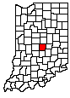
- Overview
- Enrollment & Attendance
- Student Performance
- Accountability
- School Personnel
- Historical Report Card
- Report Card
- Federal Report Card
- Annual Performance Report

Report Card
Year:
2017-2018 Report Card
A
Letter Grade
Legacy Learning Center
Legacy Learning Center received an "A" as its final letter grade for school accountability.
Overall Summary
 | Points | Weight | Weighted Points
Performance Domain Grades 3-8 | 77.20 | 0.000 | 0.00
Performance Domain Grade 10 | 0.00 | 0.000 | 0.00
Growth Domain Grade 4-8 | 145.30 | 1.000 | 145.30
Growth Domain Grade 9-12 | 0.00 | 0.000 | 0.00
Multiple Measures Domain Grade 12 | 0.00 | 0.000 | 0.00
Overall points |  |  | 145.3
Overall grade |  |  | A

Performance Domain
Elementary - Mathematics
76.5% of students passed the assessment.
This rate is above the state average.
97.2% of students participated in the assessment.
Elementary - English/Language Arts
77.9% of students passed the assessment.
This rate is above the state average.
97.2% of students participated in the assessment.

High School - Mathematics
100.0% of students passed the assessment.
This rate is above the state average.
66.7% of students participated in the assessment.
High School - English/Language Arts
100.0% of students passed the assessment.
This rate is above the state average.
83.3% of students participated in the assessment.
Growth Domain
A school's letter grade may increase, decrease, or remain the same based on student improvement.
Elementary - Mathematics
135.3 points for Top 75% Growth
160.7 points for Bottom 25% Growth
148 points for Growth
Elementary - English/Language Arts
124.4 points for Top 75% Growth
160.7 points for Bottom 25% Growth.
142.6 points for Growth

High School - Mathematics
133.3 points for Top 75% Growth
150 points for Bottom 25% Growth
141.7 points for Growth
0 points bonus for 10th-12th Grade Improvement
141.7 points for Overall Growth
High School - English/Language Arts
137.5 points for Top 75% Growth
175 points for Bottom 25% Growth.
156.3 points for Growth
0 points bonus for 10th-12th Grade Improvement
156.3 points for Overall Growth

Student Performance (3rd - 8th Grade)
Mathematics
Percent Passing
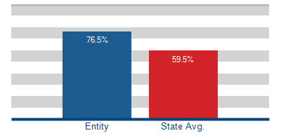
English/Language Arts
Percent Passing
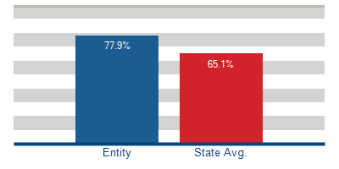
Student Performance (9th - 12th Grade)
Algebra I End-of-Course Assessment (ECA)
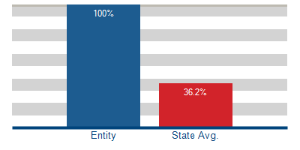
English 10 End-of-Course Assessment (ECA)
