Mathematics Grade 7
Home Learning Activities

Day 1 | Practice (Source: https://openupresources.org/math-curriculum/)  Tyler orders a meal that costs $15.  If the tax rate is 6.6%, how much will the sales tax be on Tyler’s meal?  Tyler also wants to leave a tip for the server. How much do you think he should pay in all? Explain your reasoning.  Converting a Fraction to a Decimal (Source: https://www.openmiddle.com/)  Directions: Using the digits 1 to 9, at most one time each, place a digit in each box to make a true statement.  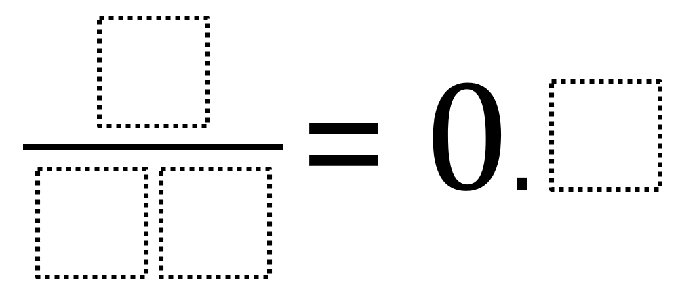  Lollipops  Joe bought 7 green lollipops. There are 3 fewer yellow lollipops than green lollipops. There are 2 more red lollipops than yellow lollipops. How many lollipops are there? Show how you got your answer.
Day 2 | Practice (Source: https://openupresources.org/math-curriculum/)  - How much higher is 500 than 400 m?  - How much higher is 500 than -400 m?  - What is the change in elevation from 8,500 m to 3,400 m?  - What is the change in elevation between 8,500 m and -300 m?  - How much higher is -200 m than 450 m?  Balancing Scales (Source: brilliant.org)  Given the balance scales below, which combination would balance five squares?  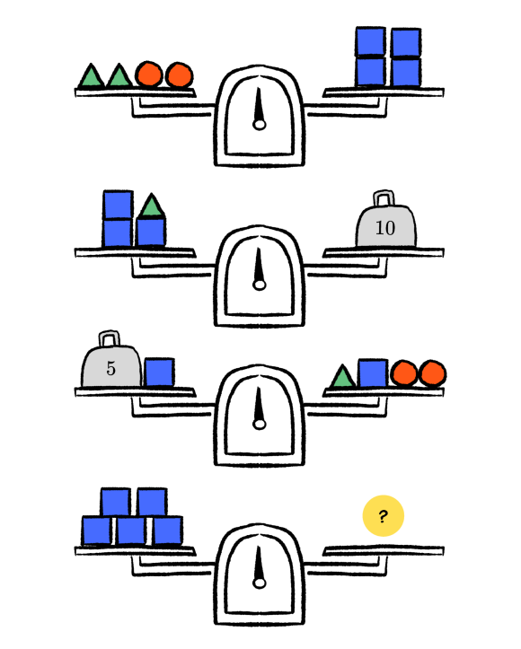  Fraction Talk (Source: http://fractiontalks.com/)  Shade in one of the regions in this square. What fraction of the big square did you shade? Explain.
Day 3 | Integer Sums and Differences (Source: https://www.openmiddle.com/)  Using the integers -3 to 3, at most one time each, fill in the blanks to make each equation true.  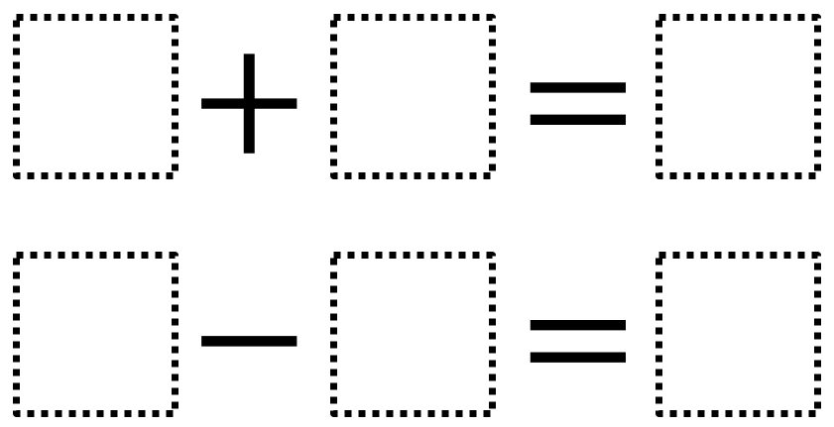  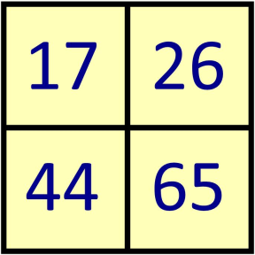  Which One Doesn’t Belong? (Source: wodb.ca)  Choose a number in this picture that you don’t think belongs with the rest. Explain why. Can you pick another number and give a different reason?  Word Problems (Source: https://openupresources.org/math-curriculum/)  The departure from the average is the difference between the actual amount of rain and the average amount of rain for a given month.  The historical average for rainfall in Albuquerque, NM for June, July, and August is shown in the table.  June July August  0.67 1.5 1.57  - Last June only 0.17 inches of rain fell all month. What is the difference between the average rainfall and the actual rainfall for last June?  - The departure from the average rainfall last July was -0.36 inches. How much rain fell last July?  - How much rain would have to fall in August so that the total amount of rain equals the average rainfall for these three months? What would the departure from the average be in August in that situation?
Day 4 | Temperature (Source: https://openupresources.org/math-curriculum/)  A weather station on the top of a mountain reports that the temperature is currently 0⁰C and has been falling at a constant rate of 3⁰C per hour. Find each temperature. Explain or show your reasoning.  - If it continues fall at this rate, what will the temperature be:  - in 2 hours?  - in 5 hours?  - in half an hour?  - What was the temperature:  - 1 hour ago?  - 3 hours ago?  - 4.5 hours ago?  Mobius Strip (Source: Critical Thinking Puzzles, Michael A. DiSpezio, 1996)  Here is one of the strangest loops you’ll ever see. It’s called a Mobius strip in honor of the German mathematician who first investigated its properties.  Image from: https://mathcraft.wonderhowto.com/  To build a Mobius strip, you need a strip of paper about 1 inch wide and 10 inches long. Coil the paper into a simple loop. Then put a single twist in the loop before securing the ends together with a piece of tape. Use a marker to color one side of the strip red and the other side blue.  Suppose you divide right down the middle of the Mobius strip. What shape would you get? Make a guess; then use a pair of scissors to carefully divide the strip.  Visual Pattern (Source: visualpatterns.org)  Below is a pattern of trees in stages 1-3 below.  - Draw what you think stage 4 might look like.  - Draw or describe what you think stage 10 might look like.  - Label how many trees are in each stage.  - Try to write an equation to describe the relationship between the stage number n and the number of trees T.  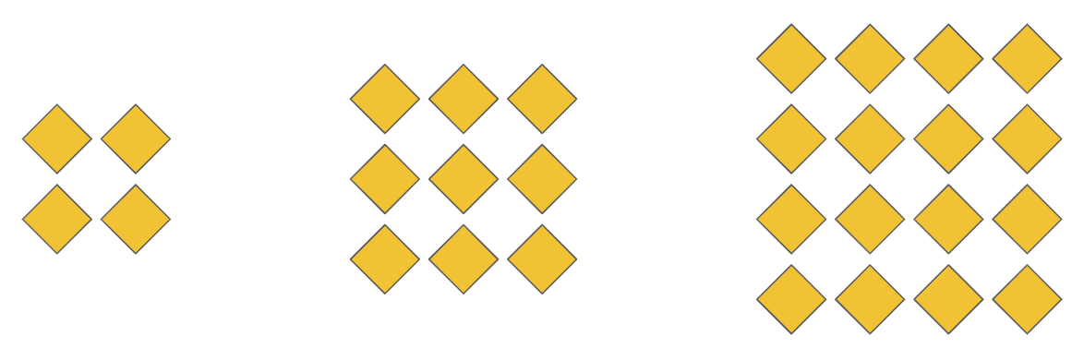
Day 5 | Graphs (Source: https://openupresources.org/math-curriculum/)  Which graphs could not represent a proportional relationship? Explain how you decided.  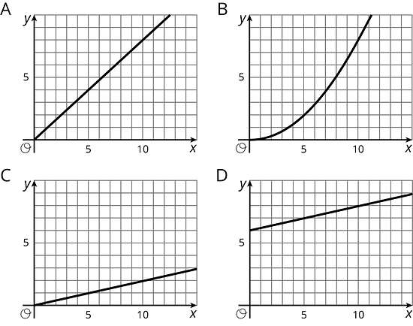  Shopping (Source: https://openupresources.org/math-curriculum/)  A shopper bought a watermelon, a pack of napkins, and some paper plates. In his state, there is no tax on food. The tax rate on non-food items is 5%. The total for the three items he bought was $8.25 before tax, and he paid $0.19 in tax. How much did the watermelon cost?  Would You Rather (Source: https://www.wouldyourathermath.com/)  Whichever option you choose, justify your reasoning with mathematics.  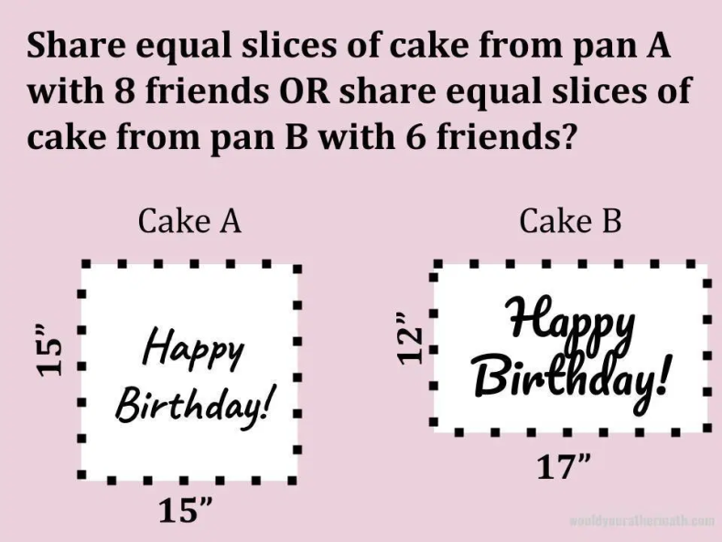

 | Mathematics Grade 7  Remote Learning Activities | WEEK 2

Day 1 | Drawing a Diagram (Source: https://openupresources.org/math-curriculum/)  A school ordered 3 large boxes of board markers. After giving 15 markers to each of 3 teachers, there were 90 markers left. The diagram represents the situation.  How many markers were originally in each box?  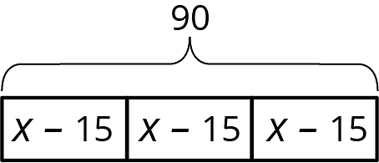  Puzzle (Source: https://www.solvemoji.com/)  What is the value of the last row?  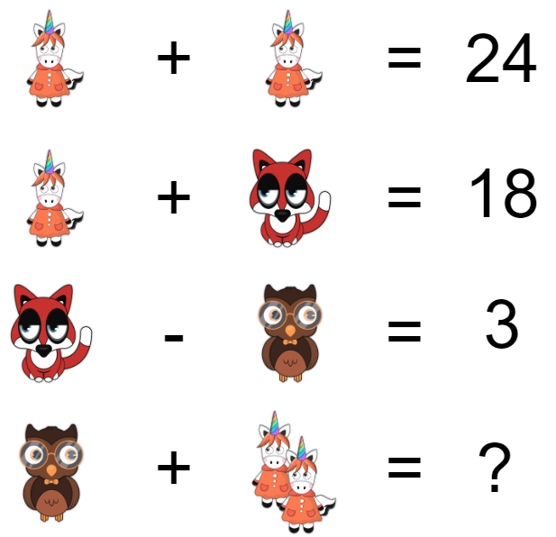  Putting It Together (Source: Critical Thinking Puzzles, Michael A. DiSpezio, 1996)  Suppose you have a list of numbers from one to one hundred. How quickly can you add them all up without using a calculator?
Day 2 | Equations (Source: https://openupresources.org/math-curriculum/)  Elena walked 20 minutes more than Lin. Jada walked twice as long as Elena. Jada walked for 90 minutes. The equation $2(x+20) = 90$ describes this situation. Match each amount in the story with the expression that represents it.  A. $x$ - The number of minutes that Jada walked  B. $$x+20$$ - The number of minutes that Elena walked  C. $$2(x+20)$$ - The number of minutes that Lin walked.  D. $$90$$  Jar of Honey (Source: brilliant.org)  A full jar of honey weighs 750 grams, and the same jar two-thirds full weighs 550 grams. What is the weight of the empty jar in grams?  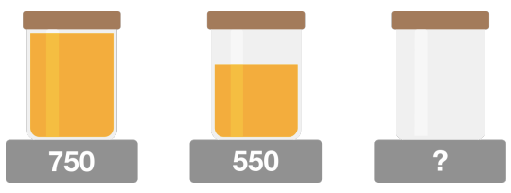  Who’s Who? (Source: https://wild.maths.org/)  We can represent a group of friends by drawing a graph.  - Each node represents a person.  - An edge joins two nodes if and only if those two people are friends.  Here is a graph showing a group of friends. Can you work out who's who using the clues below?  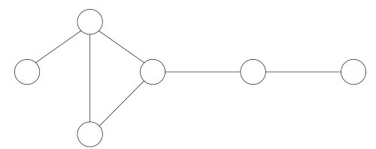  - Alan has 3 friends, Barney, Charlie, and Daniel.  - Barney and Ed are both friends with Charlie.  - Ed is Frank's only friend.
Day 3 | Which One Doesn’t Belong? (Source: wodb.ca)  Choose a number in this picture that you don’t think belongs with the rest. Explain why. Can you pick another number and give a different reason?  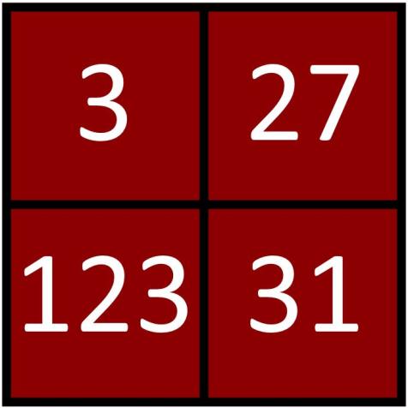  Graphs (Source: https://wild.maths.org/)  A traversable graph is one you can draw without taking your pen off the paper, and without going over any edge twice.  For each graph below, decide whether or not it is traversable. It might be helpful to keep track of where you started, the route you took, and where you finished.  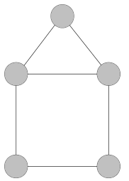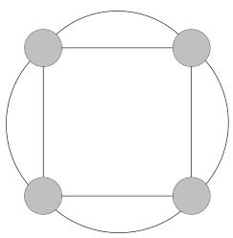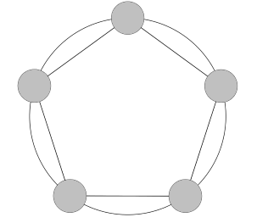  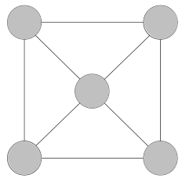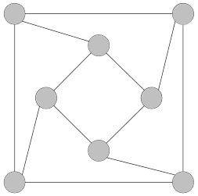  Matching Equations (Source: https://openupresources.org/math-curriculum/)  Match each equation to a story. (Two of the stories match the same equation.)  - $3(x+5)=17$  - $3x+5=17$  - $5(x+3)=17$  - $5x+3=17$  A. Jada’s teacher fills a travel bag with 5 copies of a textbook. The weight of the bag and books is 17 pounds. The empty travel bag weighs 3 pounds. How much does each book weigh?  B. A piece of scenery for the school play is in the shape of a 5-foot-long rectangle. The designer decides to increase the length. There will be 3 identical rectangles with a total length of 17 feet. By how much did the designer increase the length of each rectangle?  C. Elena spends $17 and buys a $3 book and a bookmark for each of her 5 cousins. How much does each bookmark cost?  D. Noah packs up bags at the food pantry to deliver to families. He packs 5 bags that weigh a total of 17 pounds. Each bag contains 3 pounds of groceries and a packet of papers with health-related information. How much does each packet of papers weigh?  E. Andre has 3 times as many pencils as Noah and 5 pens. He has 17 pens and pencils all together. How many pencils does Noah have?
Day 4 | Equation Puzzle (Source: brilliant.org)  Six out of seven “▢”s below contain addition signs, and the remaining “▢” contains a subtraction sign. Where should the six $+$ signs and one $-$ sign go to make the equation true?  Graphing (Source: https://openupresources.org/math-curriculum/)  There is a proportional relationship between the volume of a sample of helium in liters and the mass of that sample in grams. If the mass of a sample is 5 grams, its volume is 28 liters. (5, 28) is shown on the graph below.  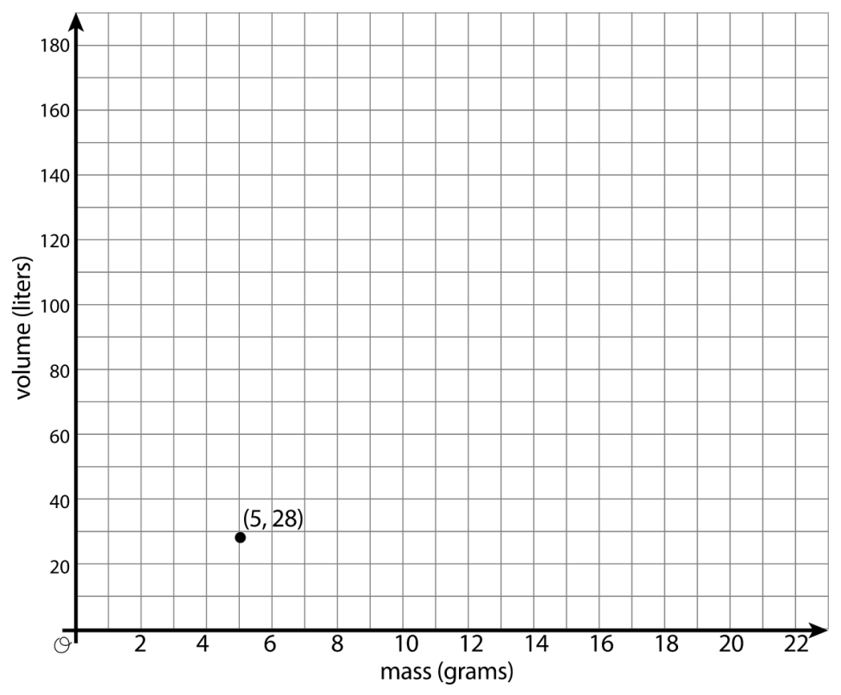  - What is the constant of proportionality in this relationship?  - In this situation, what is the meaning of the number you found in part a?  - Add at least three more points to the graph above, and label with their coordinates.  - Write an equation that shows the relationship between the mass of a sample of helium and its volume. Use $m$ for mass and $v$ for volume.  Visual Pattern (Source: visualpatterns.org)  Below is a pattern of oranges in stages 1-3 below.  - Draw what you think stage 4 might look like.  - Draw or describe what you think stage 10 might look like.  - Label how many oranges are in each stage.  - Try to write an equation to describe the relationship between the stage number n and the number of oranges O.  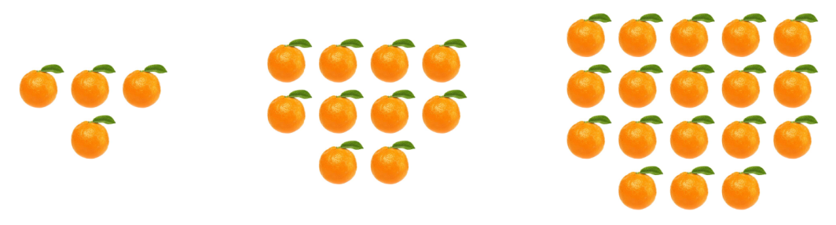
Day 5 | Balanced Hanger (Source: https://openupresources.org/math-curriculum/)  Explain how the parts of the balanced hanger compare to the parts of the equation.  $$7=2x+3$$  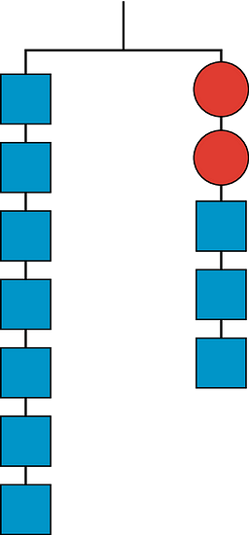  Mobile (Source: https://solveme.edc.org/Mobiles.html)  What is the value of the trapezoid? The triangle?  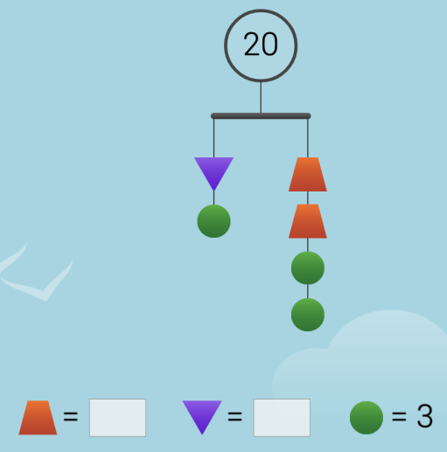  Would You Rather (Source: https://www.wouldyourathermath.com/)  Whichever option you choose, justify your reasoning with mathematics.  