Mathematics Grade 8
Home Learning Activities

Day 1 | Number Puzzle (Source: https://openupresources.org/math-curriculum/)  Tyler says he invented a number puzzle. He asks Clare to pick a number, and then asks her to do the following:  Triple the number  Subtract 7  Double the result  Subtract 22  Divide by 6  Clare says she now has a $-3$. Tyler says her original number must have been a 3. How did Tyler know that? Explain your reasoning.  Perfect Squares (Source: https://www.openmiddle.com/)  Using the digits 1- 9, at most one time each, to fill in the boxes to make each expression evaluate to a perfect square number.  Extension/Challenge: What is the largest/smallest square number you can make? How many different perfect square numbers could be made?  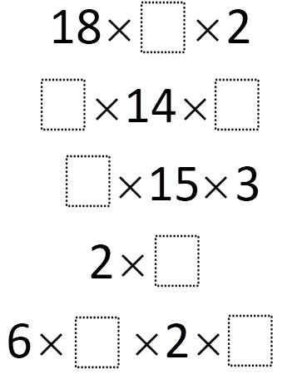  Moldy Math (Source: Critical Thinking Puzzles, Michael A. DiSpezio, 1996)  You look behind the stove and discover a slice of bread that you misplaced several weeks ago. Needless to say, it is covered with mold. Since the mold started growing, the area it has covered has doubled each day. By the end of the 8th day, the entire surface of the bread is covered. When was the bread half-covered with mold?
Day 2 | Equations (Source: https://openupresources.org/math-curriculum/)  Solve each of these equations. Explain or show your reasoning.  - $2(x+5) = 3x+1$  - $3y-4 = 6-2y$  - $3(n+2) = 9(6-n)$  Put Them in Order (Source: brilliant.org)  For two vehicles to be next to each other, they have to satisfy these rules:  - Their names share at least one letter.  - Their names do not have the same number of letters.  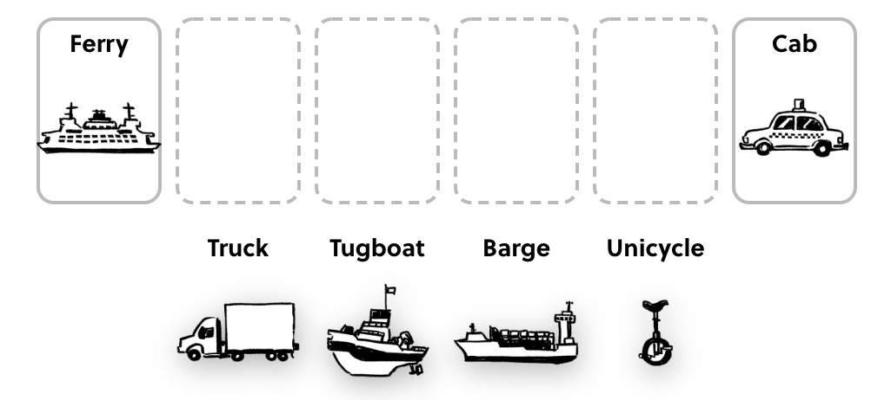  How many different orderings are possible?  Fraction Talk (Source: http://fractiontalks.com/)  What fraction of the square is shaded green? Explain.  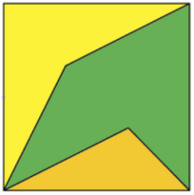
Day 3 | Pythagorean Theorem (Source: https://www.openmiddle.com/)  What could the lengths of the legs be such that the lengths are integers and x is an irrational number between 5 and 7?  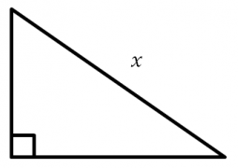  Which One Doesn’t Belong? (Source: wodb.ca)  Choose a graph in this picture that you don’t think belongs with the rest. Explain why. Can you pick another graph and give a different reason?  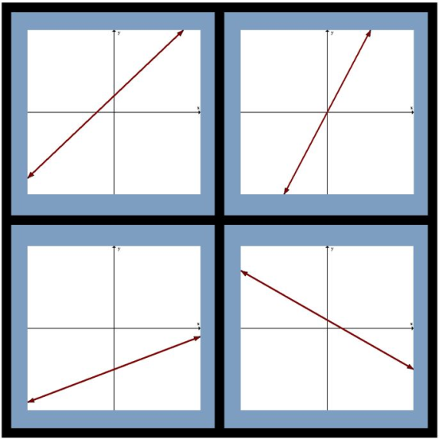  Equations (Source: https://openupresources.org/math-curriculum/)  Solve each equation, and check your solution.  - $\frac{1}{9}(2m-16) = \frac{1}{3}(2m+4)$  - $-4(r+2) = 4(2-2r)$  - $12(5+2y) = 4y-(6-9y)$
Day 4 | Temperature (Source: https://openupresources.org/math-curriculum/)  Here is the graph of a linear equation.  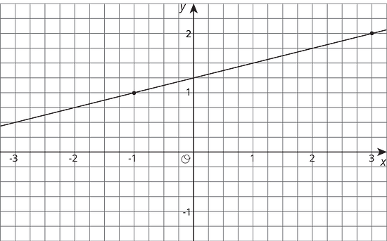  Select all true statements about the line and its equation.  - One solution of the equation is $(3, 2)$.  - One solution of the equation is $(-1, 1)$.  - One solution of the equation is $(1, \frac{3}{2})$.  - There are 2 solutions.  - There are infinitely many solutions.  - The equation of the line is $y = \frac{1}{4}x + \frac{5}{4}$.  - The equation of the line is $y = \frac{5}{4}x+\frac{1}{4}$.  Weighing Balls (Source: https://plus.maths.org/content/Puzzle)  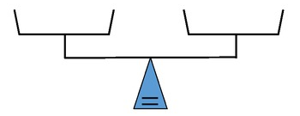  Suppose you are given eight balls and you know that one ball is slightly heavier than all the others, which are of equal weight. You're also given a balancing scale with which you can compare the weight of balls by putting some in one pan and some in the other. What's the minimum number of weighings you need to establish which ball is the heavier one?  Visual Pattern (Source: visualpatterns.org)  Below is a pattern of cylinders in stages 1-3 below.  - Draw what you think stage 4 might look like.  - Draw or describe what you think stage 10 might look like.  - Label how many cylinders are in each stage.  - Try to write an equation to describe the relationship between the stage number n and the number of cylinders C.  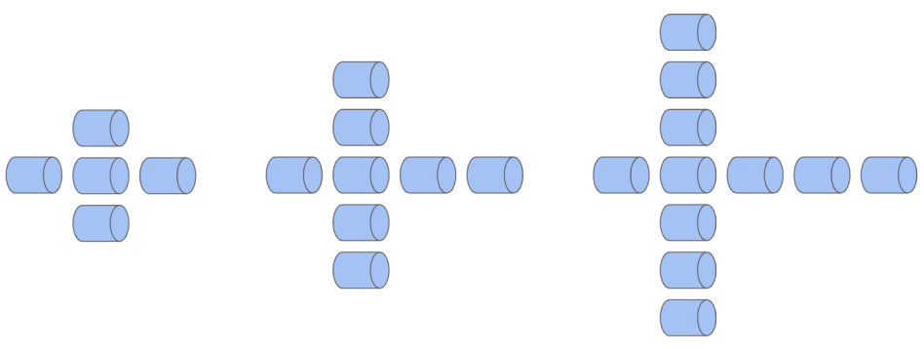
Day 5 | Word Problem (Source: https://openupresources.org/math-curriculum/)  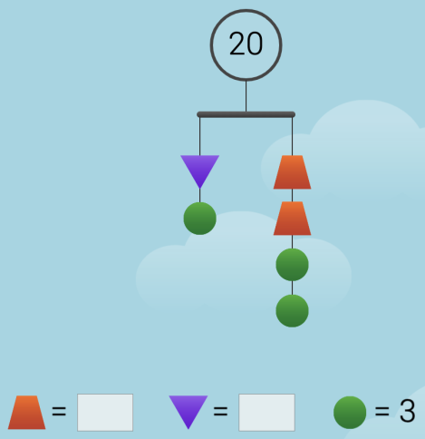  A participant in a 21-mile walkathon walks at a steady rate of 3 miles per hour. He thinks, “The relationship between the number of miles left to walk and the number of hours I already walked can be represented by a line with slope $-3$.” Do you agree with his claim? Explain your reasoning.  Mobile (Source: https://solveme.edc.org/Mobiles.html)  What is the value of the trapezoid? The triangle?  Would You Rather (Source: https://www.wouldyourathermath.com/)  Would you rather have a cube of gold that measures $25 mm$ on each side, or two cubes of gold, one is $24 mm$ per side, and one is $7 mm$ per side?  Whichever option you choose, justify your reasoning with mathematics.  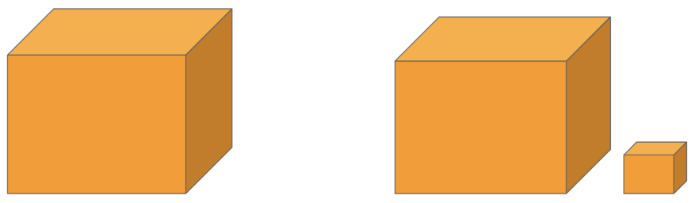

 | Mathematics Grade 8  Remote Learning Activities | WEEK 2

Day 1 | Number Puzzle (Source: https://openupresources.org/math-curriculum/)  Jada had some dimes and quarters that had a total value of $12.50. The relationship between the number of dimes, $d$, and the number of quarters, $q$, can be expressed by the equation $0.1d+0.25q = 12.5$.  - If Jada has 4 quarters, how many dimes does she have?  - If Jada has 10 quarters, how many dimes does she have?  - Is the number of dimes a function of the number of quarters? If yes, write a rule (that starts with $d=$...) that you can use to determine the output, $d$, from a given input, $q$. If no, explain why not.  - If Jada has 25 dimes, how many quarters does she have?  - If Jada has 30 dimes, how many quarters does she have?  - Is the number of quarters a function of the number of dimes? If yes, write a rule (that starts with $q=$...) that you can use to determine the output, $q$, from a given input, $d$. If no, explain why not.  Puzzle (Source: https://www.solvemoji.com/)  What is the value of the last row?  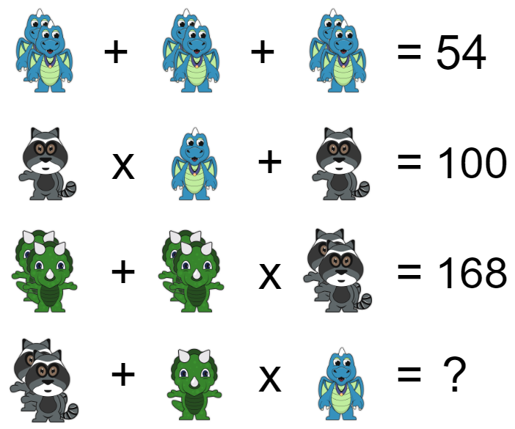  Connect the Dots (Source: Critical Thinking Puzzles, Michael A. DiSpezio, 1996)  Starting at the top center dot, can you connect all of the other nine dots with only four straight lines? The four lines must all be connected and your pencil can’t leave the paper while drawing the answer.  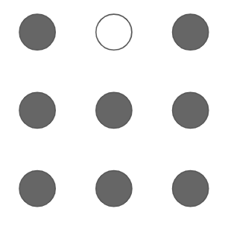
Day 2 | Equations (Source: https://openupresources.org/math-curriculum/)  Brown rice costs $2 per pound, and beans cost $1.60 per pound. Lin has $10 to spend on these items to make a large meal of beans and rice for a potluck dinner. Let $b$ be the number of pounds of beans Lin buys and $r$ be the number of pounds of rice she buys when she spends all her money on this meal.  - Write an equation relating the two variables.  - Rearrange the equation so $b$ is the independent variable.  - Rearrange the equation so $r$ is the independent variable.  Fit the Pieces Together (Source: brilliant.org)  The four puzzle pieces below fit into the 4 x 4 grid without rotation or reflection.  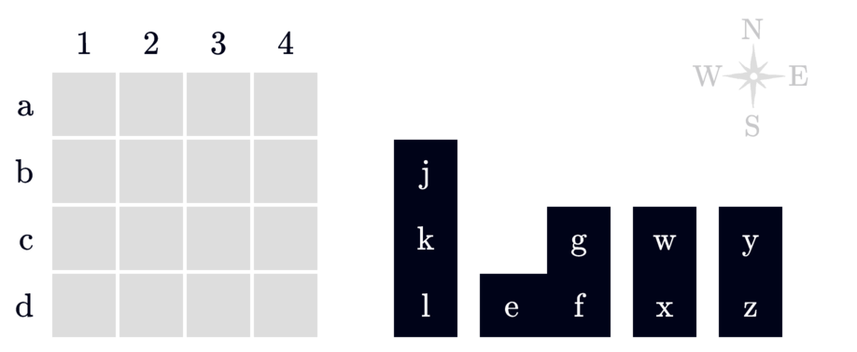  Based on these clues, where is E located?  - K touches W and G (they can touch diagonally).  - F touches L and Z (they can touch diagonally).  - X does not touch K, even diagonally.  - Y is in a row below K's row.  Fraction Talk (Source: http://fractiontalks.com/)  What fraction of the square is shaded by each color? How do you know?  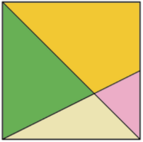
Day 3 | Which One Doesn’t Belong? (Source: wodb.ca)  Choose a graph in this picture that you don’t think belongs with the rest. Explain why. Can you pick another graph and give a different reason?  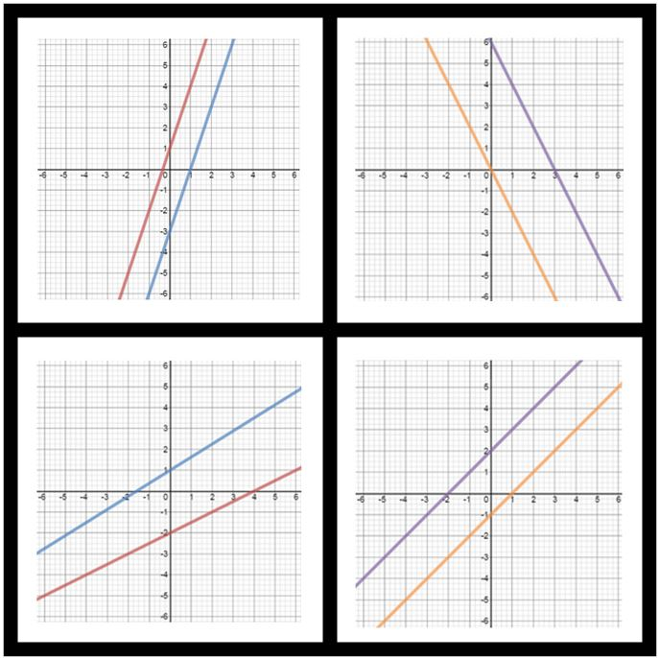  Magic 19 (Source: https://plus.maths.org/content/Puzzle)  Here are 19 dots arranged in a hexagon. Your task is to label the dots with the numbers 1 to 19 so that each set of three dots that lie along a straight-line segment add up to 22.  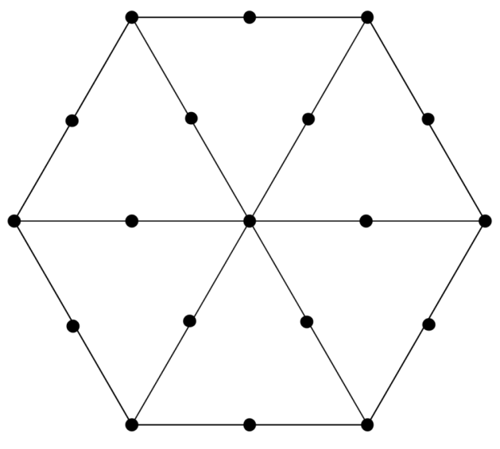  Equations (Source: https://openupresources.org/math-curriculum/)  Solve each equation, and check your solution.  - $2x+4(3-2x) = \frac{3(2x+2)}{6}+4$  - $4z+5 = -3z-8$  - $\frac{1}{2}-\frac{1}{8}q = \frac{q-1}{4}$
Day 4 | Equal Averages (Source: https://plus.maths.org/content/Puzzle)  There are several different notions of average: the mean, the median, the mode and the range. If you work out each of these for the set of numbers 2, 5, 5, 6, 7, you'll notice something interesting — they are all equal to 5!  Can you find other sets of five positive whole numbers where mean = median = mode = range?  Graphing (Source: https://openupresources.org/math-curriculum/)  - Graph a system of linear equations with no solutions.  - Write an equation for each line you graph.  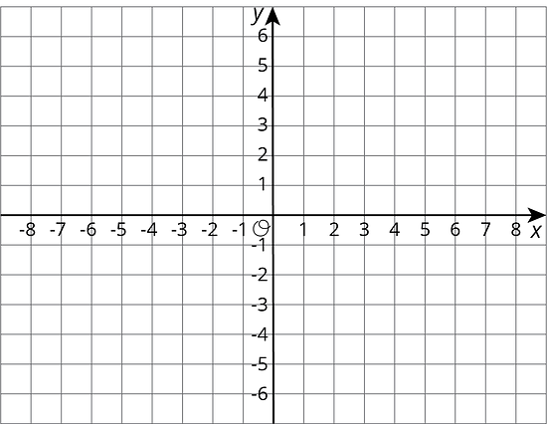  Visual Pattern (Source: visualpatterns.org)  Below is a pattern of cubes in stages 1-3 below.  - Draw what you think stage 4 might look like.  - Draw or describe what you think stage 10 might look like.  - Label how many cubes are in each stage.  - Try to write an equation to describe the relationship between the stage number n and the number of cubes C.  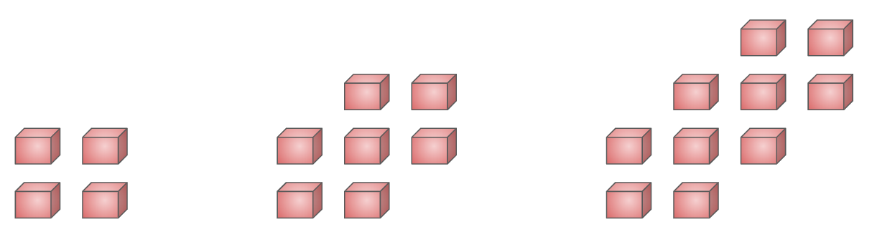
Day 5 | Word Problem (Source: https://openupresources.org/math-curriculum/)  The graphs of three functions are shown.  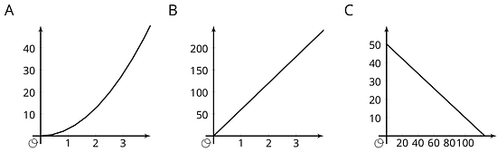  - Match each of these equations to one of the graphs.  - $d=60t$, where is the distance in miles that you would travel in $t$ hours if you drove at 60 miles per hour.  - $q=50-0.4d$, where $d$ is the number of quarters, and is the number of dimes, in a pile of coins worth $12.50.  - $A=πr$², where $A$ is the area in square centimeters of a circle with radius $r$ centimeters.  - Label each of the axes with the independent and dependent variables and the quantities they represent.  - For each function: What is the output when the input is 1? What does this tell you about the situation? Label the corresponding point on the graph.  - Find two more input-output pairs. What do they tell you about the situation? Label the corresponding points on the graph.  Mobile (Source: https://solveme.edc.org/Mobiles.html)  What is the value of the square? The crescent?  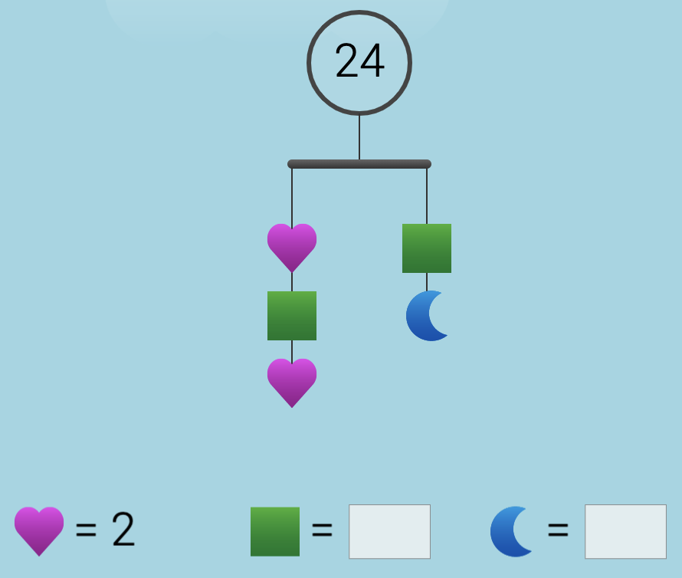  Would You Rather (Source: https://www.wouldyourathermath.com/)  Whichever option you choose, justify your reasoning with mathematics.  