Mathematics Grade 6
Home Learning Activities

Day 1 | Practice (Source: https://openupresources.org/math-curriculum/)  Select all the true equations.  - $5 + 0 = 0$  - $15 ⋅ 0 = 0$  - $1.4 + 2.7 = 4.1$  - $\frac{2}{5} ⋅ \frac{5}{9} = \frac{7}{12}$  - $4\frac{2}{3} =5 -\frac{1}{3}$  Equivalent Ratios (Source: https://www.openmiddle.com/)  Using each of the digits 0-6 only once, make two equivalent ratios (also known as a proportion).  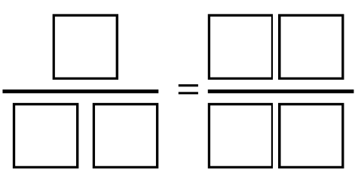  Eightfold (Source: https://playwithyourmath.com/)  Try this challenge!  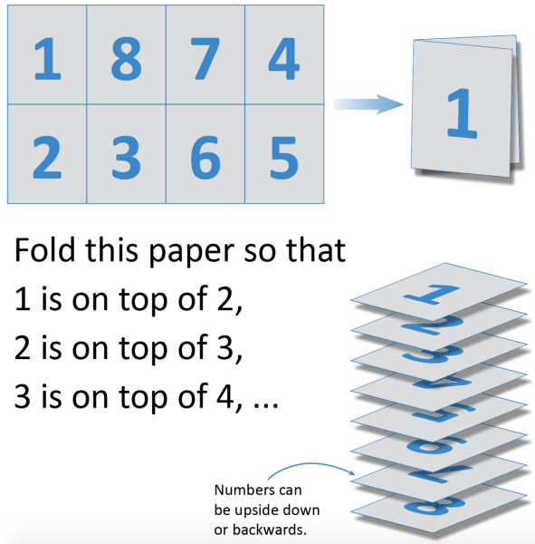
Day 2 | Expression (Source: https://openupresources.org/math-curriculum/)  Mai's water bottle had 24 ounces in it. After she drank ounces of water, there were 10 ounces left. Select all the equations that represent this situation.  - $24 ÷10 = x$  - $24 +10 = x$  - $24 -10 = x$  - $x + 10 = 24$  - $10x = 24$  Odd Pig Out Game (Source: mathforlove.org)  Roll two dice and multiply them. You can keep rolling as long as the product is even. If the product is odd, you lose all unbanked points for that turn, and pass the dice. Play to 500.  Fraction Talk (Source: http://fractiontalks.com/)  Shade in one of the regions in this square. What fraction of the big square did you shade? Explain.
Day 3 | Decimal Addition (Source: https://www.openmiddle.com/)  Use the digits, 0 through 9, without repeats, to complete the equation below:  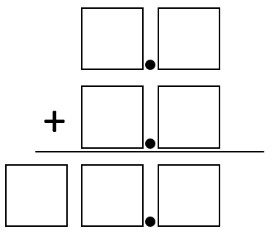  Which One Doesn’t Belong? (Source: wodb.ca)  Choose a number in this picture that you don’t think belongs with the rest. Explain why. Can you pick another number and give a different reason?  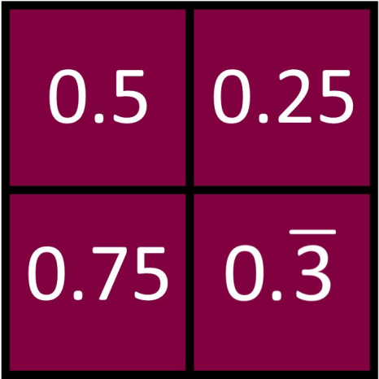  Word Problem (Source: https://openupresources.org/math-curriculum/)  The daily recommended allowance of vitamin C for a sixth grader is 45 mg. 1 orange has about 75% of the recommended daily allowance of vitamin C. How many milligrams are in 1 orange? If you get stuck, consider using the double number line.
Day 4 | Percent Problems (Source: https://openupresources.org/math-curriculum/)  There are 90 kids in the band. 20% of the kids own their own instruments, and the rest rent them.  - How many kids own their own instruments?  - How many kids rent instruments?  - What percentage of kids rent their instruments?  One Big Factor Family (Source: https://playwithyourmath.com/)  Imagine that each number has a family.  - Its children are its factors that are not equal to itself.  - Some numbers have grandchildren…  - … and great-grandchildren  - There are four 1s in the 8’s family  How many 1s are in the 72’s family?  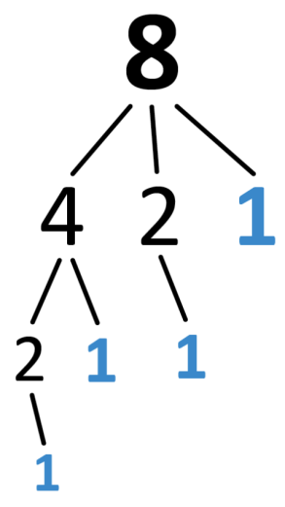  Visual Pattern (Source: visualpatterns.org)  Below is a pattern of trees in stages 1-3 below.  - Draw what you think stage 4 might look like.  - Draw or describe what you think stage 10 might look like.  - Label how many trees are in each stage.  - Try to write an expression to describe the relationship between the stage number n and the number of trees T.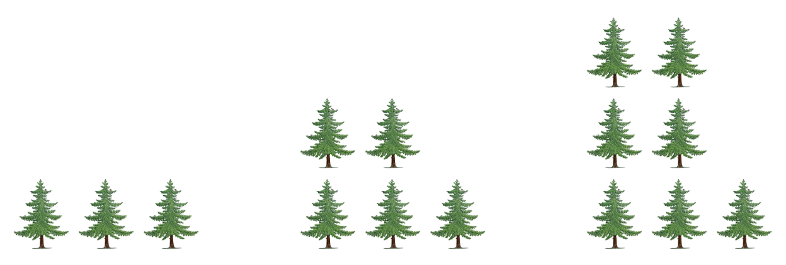
Day 5 | Balance (Source: https://openupresources.org/math-curriculum/)  Here is a balanced hanger.  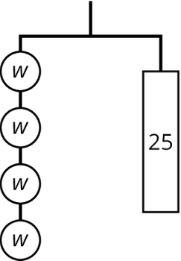  - Write an equation representing this hanger.  - Find the weight of one circle. Show or explain how you found it.  Writing Equations (Source: https://openupresources.org/math-curriculum/)  Write an equation to represent each hanger.  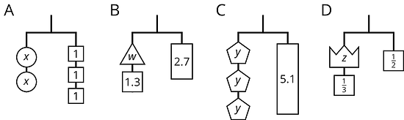  Would You Rather (Source: https://www.wouldyourathermath.com/)  Whichever option you choose, justify your reasoning with mathematics.  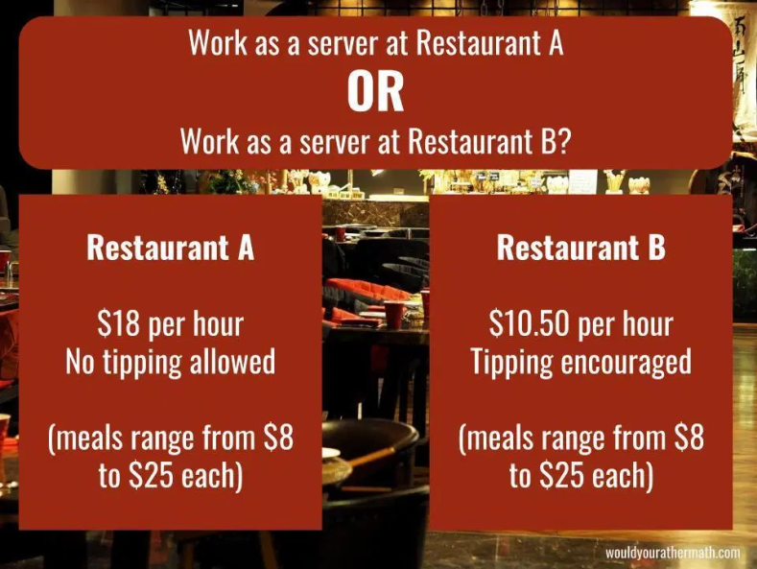

 | Mathematics Grade 6  Remote Learning Activities | WEEK 2

Day 1 | Equations (Source: https://openupresources.org/math-curriculum/)  Select all the equations that describe each situation and then find the solution.  Kiran’s backpack weighs 3 pounds less than Clare’s backpack. Clare’s backpack weighs 14 pounds. How much does Kiran’s backpack weigh?  - $x+3=14$  - $3x=14$  - $x=14-3$  - $x=14÷3$  - Each notebook contains 60 sheets of paper. Andre has 5 notebooks. How many sheets of paper do Andre’s notebooks contain?  - $y=60÷5$  - $y=5⋅60$  - $\frac{y}{5}=60$  - $5y=60$  Order of Operations (Source: https://www.openmiddle.com/)  Using the digits 1 to 5, at most one time each, place a digit in each box to create an expression with the largest possible value.  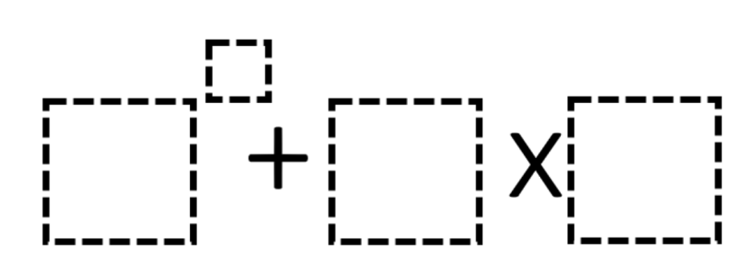  Scale (Source: https://brilliant.org/)  What weight will the fourth scale display?  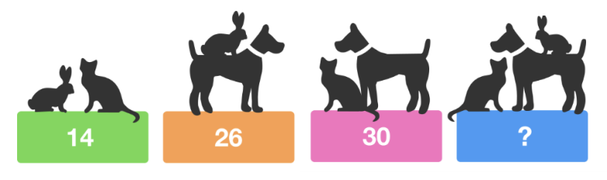
Day 2 | Equations (Source: https://openupresources.org/math-curriculum/)  Solve each equation.  - $2x=5$  - $y+1.8=14.7$  - $6=\frac{1}{2}z$  - $3\frac{1}{4}=\frac{1}{2}+w$  - $2.5t=10$  Gold Chest (Source: https://brilliant.org/)  Exactly one of these chests contains gold, but only one of the four statements is true. Which chest must contain the gold?  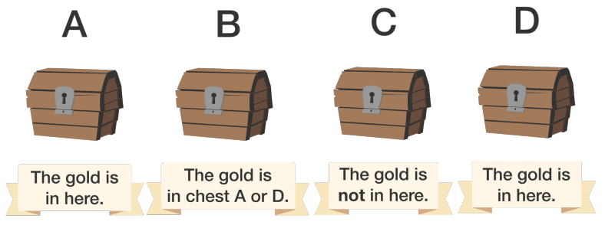  Lots of Lollies (Source: https://wild.maths.org/)  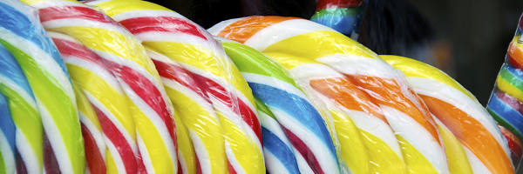  Frances and Rishi were given a bag of lollies. They shared them out evenly and had one left over.  Just as they had finished sharing them, their friends Kishan, Hayley and Paul came along. They wanted some lollies too so the children shared them out again between all of them. This time they had two lollies left over.  How many lollies could there have been in the bag?
Day 3 | 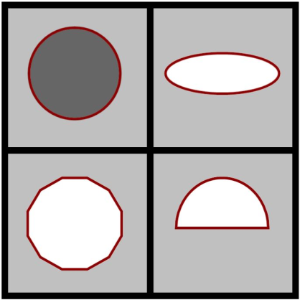  Which One Doesn’t Belong? (Source: wodb.ca)  Choose a shape in this picture that you don’t think belongs with the rest. Explain why. Can you pick another shape and give a different reason?  Solving One-Step Equation (Source: https://www.openmiddle.com/)  Use the digits 1 to 9, at most one time each, to create an equation where x has the greatest possible value.  Product (Source: https://openupresources.org/math-curriculum/)  Find each product.  - $(21.2)⋅(0.02)$  - $(2.05) ⋅(0.004)$
Day 4 | Even and Odd (Source: https://brilliant.org/)  Can an even number, divided by another even number, times another even number ever equal an odd number? What are your thoughts?  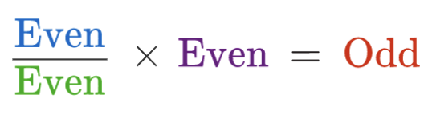  Equations (Source: https://openupresources.org/math-curriculum/)  Solve each equation.  - $4x=32$  - $4=32x$  - $10x=26$  - $26=100x$  Visual Pattern (Source: visualpatterns.org)  Below is a pattern of peaches in stages 1-3 below.  - Draw what you think stage 4 might look like.  - Draw or describe what you think stage 10 might look like.  - Label how many peaches are in each stage.  - Try to write an equation to describe the relationship between the stage number n and the number of oranges P.  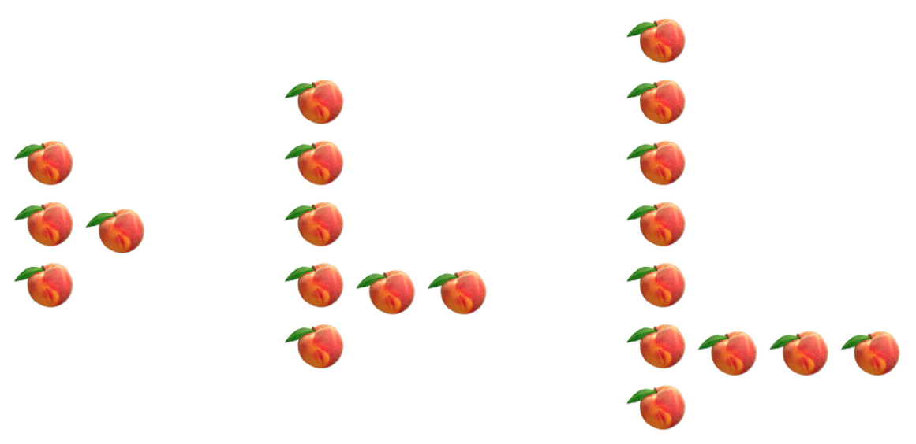
Day 5 | Fundraiser (Source: https://openupresources.org/math-curriculum/)  Write as many mathematical expressions or equations as you can about the image. Include a fraction, a decimal number, or a percentage in each.  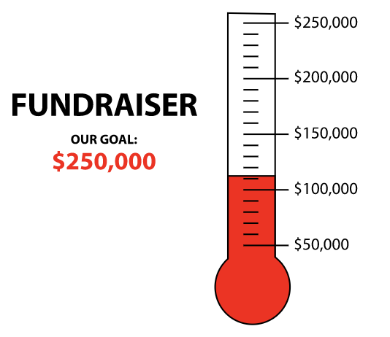  Paint Mixture (Source: https://openupresources.org/math-curriculum/)  In a lilac paint mixture, 40% of the mixture is white paint, 20% is blue, and the rest is red. There are 4 cups of blue paint used in a batch of lilac paint. If you get stuck, consider using a tape diagram.  - How many cups of white paint are used?  - How many cups of red paint are used?  - How many cups of lilac paint will this batch yield?  Would You Rather (Source: https://www.wouldyourathermath.com/)  Would you rather buy one 8-lb container of ice cream for $24.56, or two 3-lb 11-oz containers of ice cream for $23.60?  Whichever option you choose, justify your reasoning with mathematics.  